Issue 1: Soft_deletes_flag are not working fine :

SELECT distinct SRC.NOTICE_STATUS,SRC.cdctype,TRGT.soft_deleted_flag AS Dim,fact.soft_deleted_flag AS Fact_Sof

FROM pandg_mdsdb.pg_mega_pgb_application_rita_final SRC

LEFT JOIN pandg_mdwdb.d_rita_application_c TRGT ON SRC.NAME=TRGT.row_id AND SRC.sourceinstance=TRGT.source_id

LEFT JOIN pandg_mdwdb.d_lov LKP

ON CONCAT('OT_CONTROL_STATUS_C','~','PROCESSING_ACTIVITIES','~',SRC.NOTICE_STATUS)=LKP.row_id

AND SRC.sourceinstance=LKP.source_id

JOIN pandg_mdwdb.f_rita_application_c fact ON TRGT.row_key=fact.rita_application_c_key AND TRGT.source_id=fact.source_id

group by 1,2

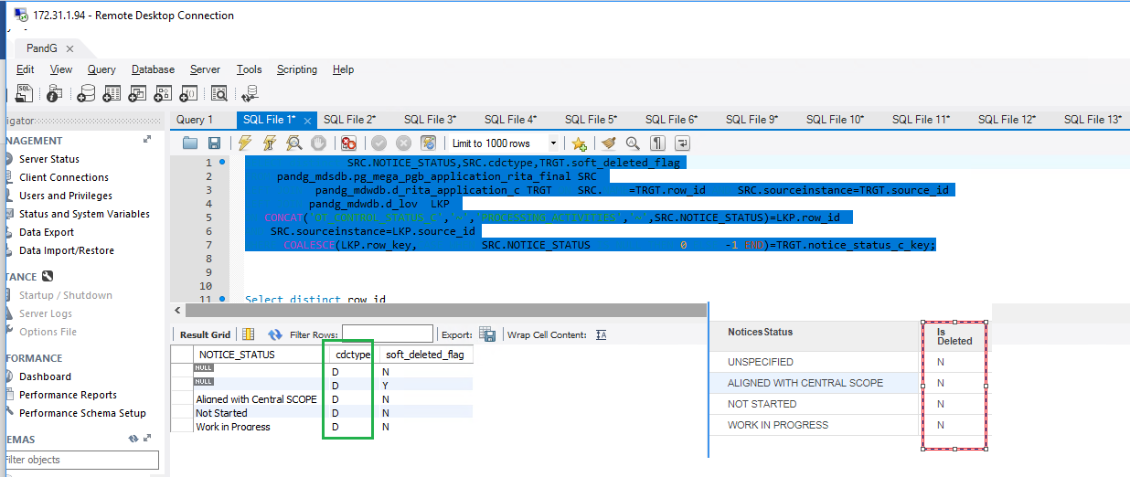

Issue 2: QA Code failed for 1 record for data_retention_status_c_key

SELECT SRC.DATA_RETENTION_STATUS,LKP.row_key,COALESCE(LKP.row_key,CASE WHEN upper(SRC.DATA_RETENTION_STATUS) IS NULL THEN 0 ELSE -1 END),TRGT.data_retention_status_c_key,

Count(1) as CNT

FROM pandg_mdsdb.pg_mega_pgb_application_rita_final SRC

LEFT JOIN pandg_mdwdb.d_rita_application_c TRGT ON SRC.NAME=TRGT.row_id AND SRC.sourceinstance=TRGT.source_id

JOIN pandg_mdwdb.d_lov LKP ON

COALESCE(CONCAT('OT_CONTROL_STATUS_C~PROCESSING_ACTIVITIES~',UPPER(SRC.DATA_SUBJ_RIGHTS_STATUS)),'UNSPECIFIED')=LKP.row_id

AND SRC.sourceinstance=LKP.source_id

WHERE COALESCE(LKP.row_key,CASE WHEN upper(SRC.DATA_RETENTION_STATUS) IS NULL THEN 0 ELSE -1 END)<>TRGT.data_retention_status_c_key

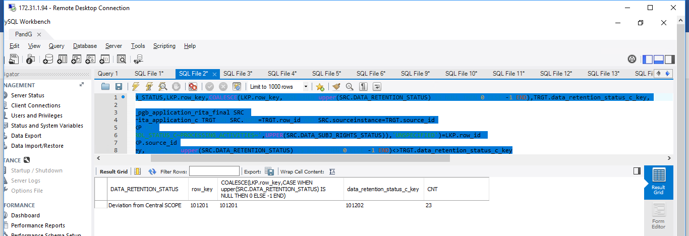

Issue 3 ‘Data Subject Right Results’ attribute is only UNKNOWN

SELECT DATA_SUBJ_RIGHTS_STATUS,

Count(1) as CNT

FROM pandg_mdsdb.pg_mega_pgb_application_rita_final SRC

LEFT JOIN pandg_mdwdb.d_rita_application_c TRGT ON SRC.NAME=TRGT.row_id AND SRC.sourceinstance=TRGT.source_id

LEFt JOIN pandg_mdwdb.d_lov LKP ON

COALESCE(CONCAT('OT_CONTROL_STATUS_C~PROCESSING_ACTIVITIES~',UPPER(SRC.DATA_SUBJ_RIGHTS_STATUS)),'UNSPECIFIED')=LKP.row_id

AND SRC.sourceinstance=LKP.source_id

group by 1;

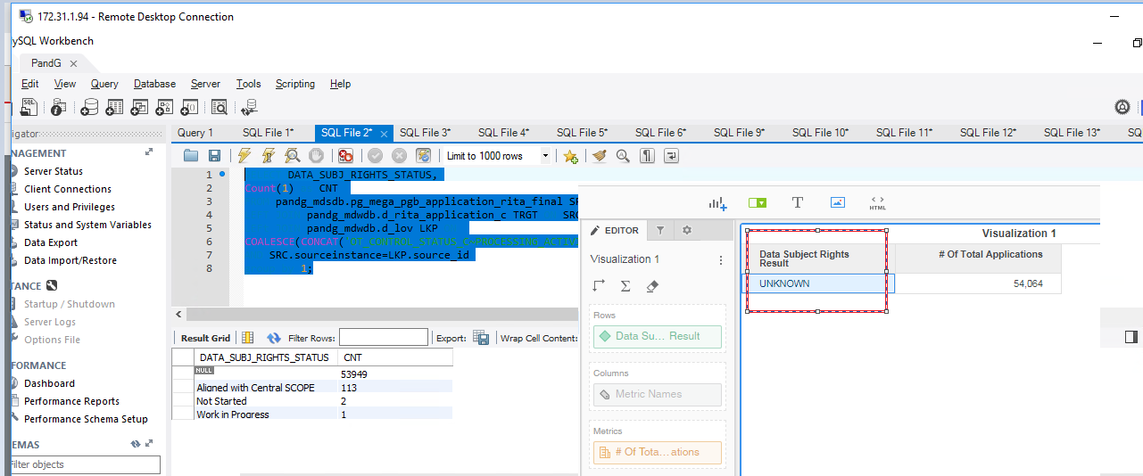

Issue 4: Multiple form issues on ‘Data Ren tension Status’

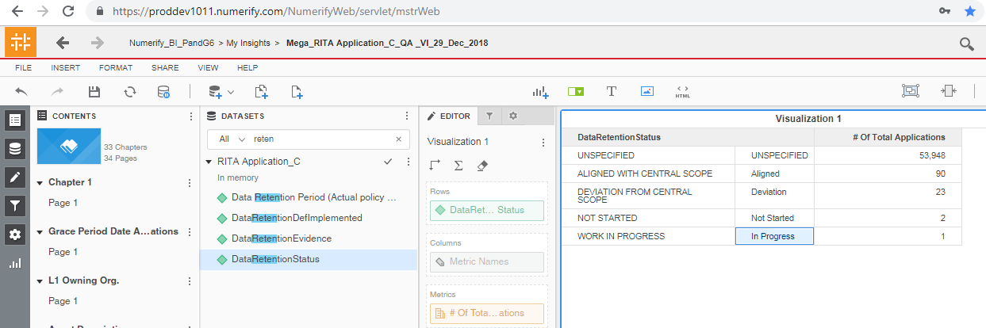

Issue 5: Dpia Status and Dpia Result are having the same values .

Share the backend column name for ‘Dpia Result’

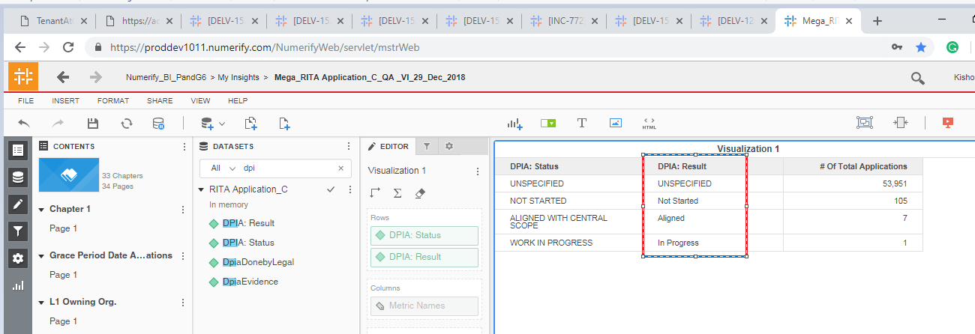

Observations 1: Noticed Nulls in Comments Section :

SELECT COALESCE(SRC.COMMENTS,'UNSPECIFIED'),TRGT.comments,Count(1) as CNT

FROM pandg_mdsdb.pg_mega_pgb_application_rita_final SRC

LEFT JOIN pandg_mdwdb.d_rita_application_c TRGT ON SRC.NAME=TRGT.row_id AND SRC.sourceinstance=TRGT.source_id

group by 1,2;

